MEKONG DELTA: 2 DAYS 1 NIGHT
MY THO – BEN TRE – CAN THO – CAI RANG FLOATING MARKET

DAY 1: TP HCM – MY THO – BEN TRE
Morning: 07:00
- Departing from 202, Le Lai Street, District 1 to My Tho City.
- Taking rest at Mekong Rest Stop for rest-room, breakfast (self-sufficient).
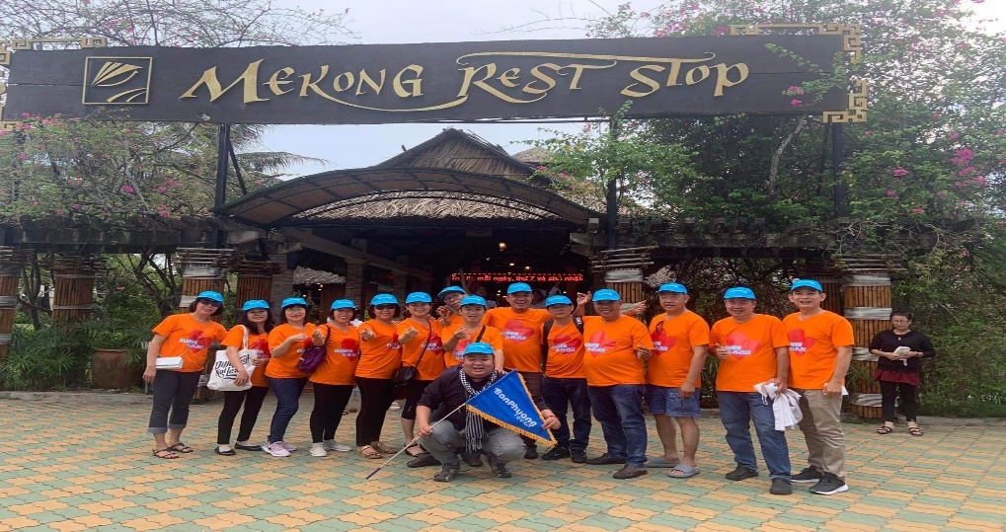
- Coming to Chuong Duong boat station in My Tho City taking a boat and having a sightseeing on Tien River, you may contemplate the landscape of four famous islands; they are Dragon Island, Phoenix Island, Turtle Island and Unicorn Island. Besides that, you may have a look at Rach Mieu Bridge – the first structure that Vietnamese engineers built to across Tien River.
- The boat will dock at Unicorn Island, firstly, you may visit the honey bee farm and enjoy the honey tea moving on to the coconut candy workshop to discover the process that local people produce the candy.
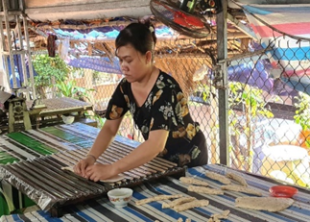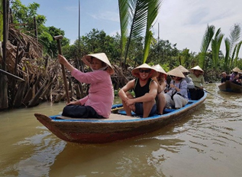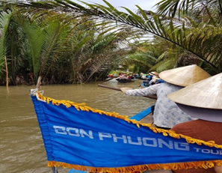
- Next, going to the orchard garden, you may enjoy the seasonal fruit as well as they will serve you the traditional music of the Southwest of Vietnam Then, you may join the horse cart to go around the village After all, you will finish the trip on Unicorn Island by rowing dinghy in the small canal under the Nipas’ leaves.
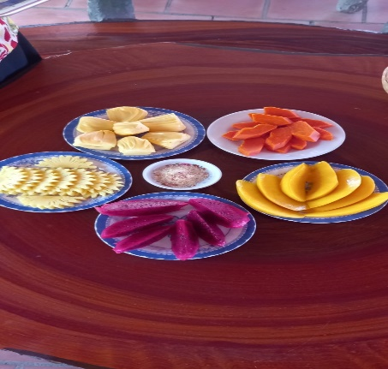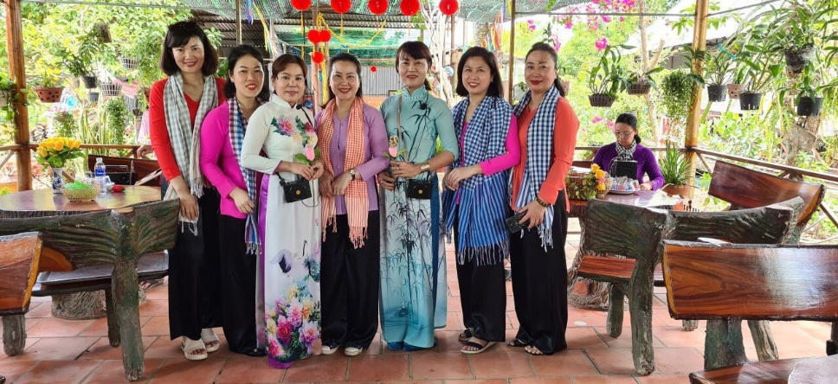
Afternoon:
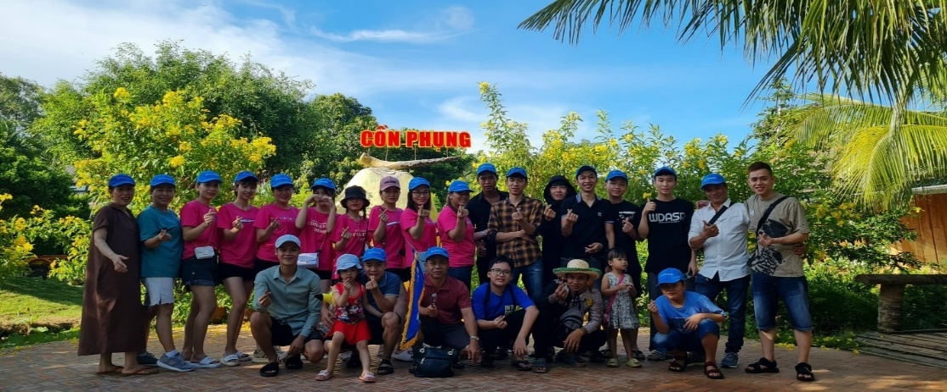
- Moving on to the Phoenix Island, this is the Eco-tourism area, you may visit the Coconut Religion’s relic.
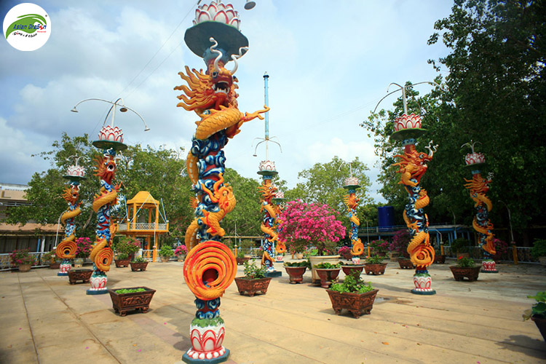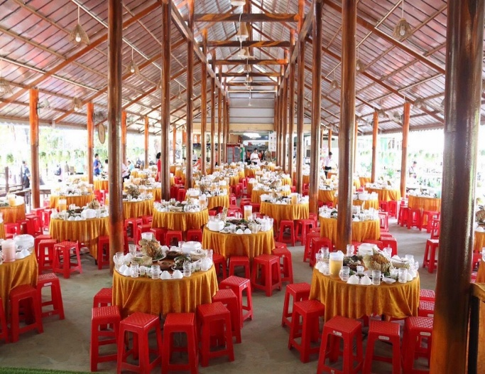
- Having lunch at the Phoenix Island’s restaurant after lunch, you have free time to discover and take part in some entertained activities, such as crocodile farm, monkey - bridge, etc. or you may take a rest on free hammock.
- Returning to My Tho City, you will visit Vinh Trang pagoda – the largest as well as oldest pagoda in Tien Giang province. It is famous for the special architecture that mixed Khmer styles and French styles.
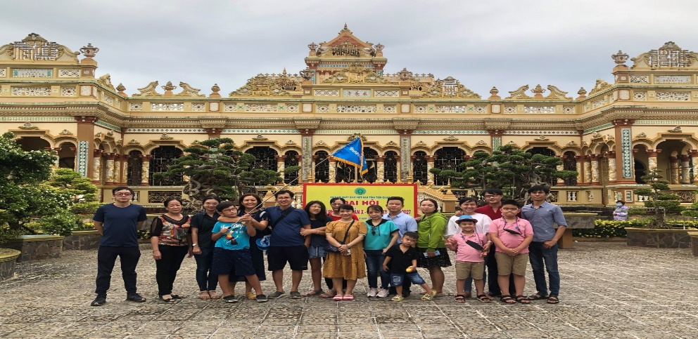
- Depart to Can Tho City.
- Check – in hotel, you will have a dinner at Can Tho Restaurant Cruise. After dinner, you may go around and discover Can Tho City’s night by yourself.
Day 2: CAN THO – FLOATING MARKET
Morning:
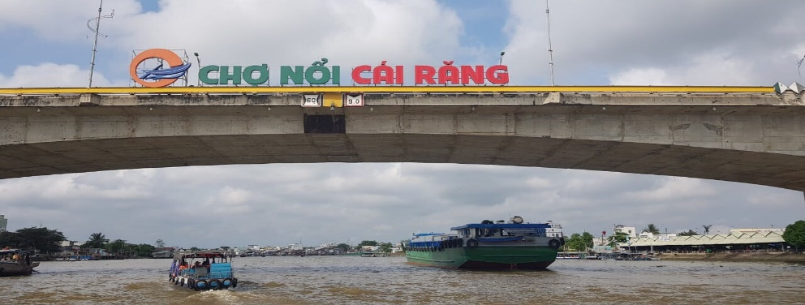
- Having breakfast at your hotel.
- Going to Ninh Kieu Wharf and taking boat to go sightseeing on Can Tho River.
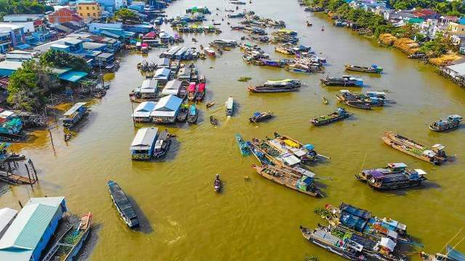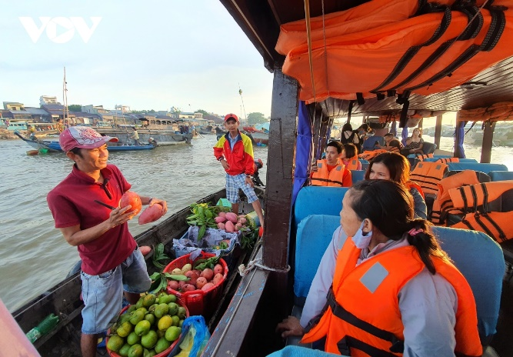
- Visiting the floating market – typical trading of the River region, you may find out more interest information about the floating market, such as history or some fairy tales about floating market.
- Visiting the rice paper noodles workshop, you may see all the process that making noodles.
- Moving on to Son Island, you will enjoy the special performance – called “the flying snack-head fish” and go around the orchard garden freely.
Afternoon:
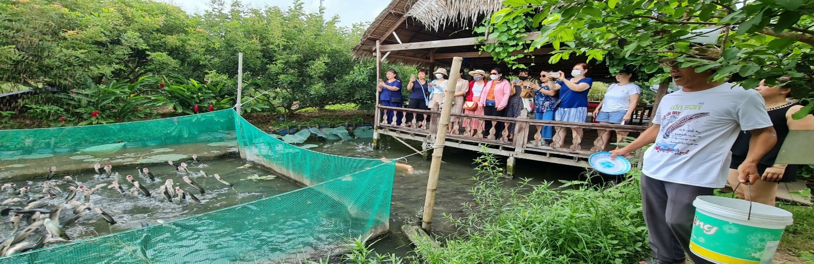
- Having lunch at Son Island’s restaurant with the special local dishes.
- Return to Ho Chi Minh City and finish the 2-days-1-night tour in the Southwest of Vietnam.
Included: A/C bus, 1 water, tour guide speaking English, boat trip, entrance fee, lunch and dinner in first day, 1 lunch in second day, 1 breakfast at hotel in Can Tho, hotel (2 or 3 star, 2-3 people per room).
Excluded: Tip, pay extra single room.

