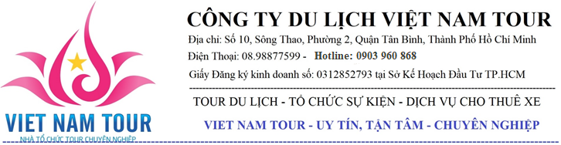

MEKONG DELTA 1 DAY | MY THO – BEN TRE
DAY 1: HCM – MY THO – BEN TRE
Morning: 07:00
• Departing from 202, Le Lai Street, District 1 to My Tho City.
• Taking rest at Mekong Rest Stop for rest-room, breakfast (self-sufficient).
• Coming to Chuong Duong boat station in My Tho City → taking a boat and having a
sightseeing on Tien River, you may contemplate the landscape of four famous island, they are
Dragon Island, Phoenix Island, Turtle Island and Unicorn Island. Besides that, you may
have a look at Rach Mieu Bridge – the first structure that Vietnamese engineers built to across
Tien River.
• The boat will dock at Unicorn Island, firstly, you may visit the honey bee farm and enjoy
the honey tea → moving on to the coconut candy workshop to discover the process that
local people produce the candy.
• Next, going to the orchard garden, you may enjoy the seasonal fruit as well as they will
serve you the traditional music of the Southwest of Vietnam → Then, you may join the
horse cart to go around the village → After all, you will finish the trip on Unicorn Island by
rowing dinghy in the small canal under the Nipas’ leaves.
Afternoon:
• Moving on to the Phoenix Island, this is the Eco-tourism area, you may visit the Coconut
Religion’s relic.
• Having lunch at the Phoenix Island’s restaurant → after lunch, you have free time to discover
and take part in some entertained activities, such as crocodile farm, monkey - bridge, etc. or
you may take a rest on free hammock.
• Returning to My Tho City. Visiting the beautiful Vinh Trang Pagoda which was
built in 1849.
• Say goodbye Mekong Delta one-day-trip. We will return to HCM city by bus. Thank you
– see you again.
◻ Included: A/C bus, water, tour guide speaking English, boat trip, entrance fee, lunch.
◻ Excluded: Tip, soft drinks, shopping.
Lunch’s menu:
▪ Fried Giant Gourami + fresh vegetables + rice vermicelli + tamarind sauce;
▪ Spring rolls;
▪ Meat stew;
▪ Fried sticky rice;
▪ Sweet and sour hot pot;
▪ Boiled vegetables + braised fish sauce;
▪ Rice + iced tea;
▪ Desert: fruit.

